# OPERATING SYSTEM WEEK 12 ASSIGNMENT

# What is Thrashing? When a process said to be thrashed and discuss the in details about the various solutions for thrashing?

* If a process does not have “enough” pages, the page-fault rate is very high.

This leads to:low CPU utilization.

* operating system thinks that it needs to increase the degree of multiprogramming.
* another process added to the system.
* Thrashing º a process is busy swapping pages in and out.
* This high paging activity is called thrashing.
* 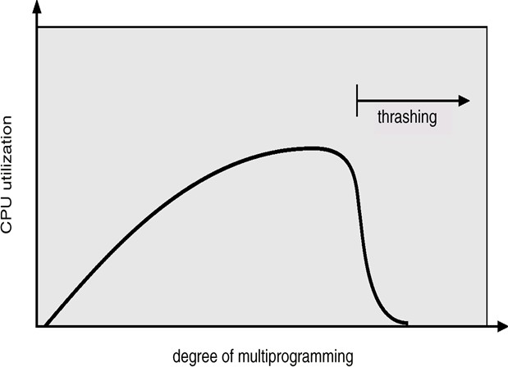A process is thrashing if it is spending more time paging than executing.

Image while(true)

{

/* produce an item in next produced */ while (counter == BUFFER_SIZE) ;

/* do nothing */ buffer[in] = next_produced;

in = (in + 1) % BUFFER_SIZE;

counter++;

}

* We can limit the effects of thrashing by using a local replacement algorithm (or priority replacement algorithm).
* local replacement - if one process starts thrashing, it cannot steal frames from another process to thrash.
* This problem is not entirely solved. If processes are thrashing, they will be in the queue for the paging device most of the time.
* The average service time for a page fault will increase. Thus, the effective access time will increase even for a process that is not thrashing.

# Given the reference to the following pages by a program 0, 9, 0, 1, 8, 1, 8, 7, 8, 7, 1, 2, 8, 2, 7, 8, 2, 3, 8, 3. There are 3 page frames in memory. Calculate the number of page faults occurs with respect to Optimal Page Replacement Algorithm and FIFO Page Replacement Algorithm.

0 9 0 1 8 1 8 7 8 7 1 2 8 2 7 8 2 3 8 3

|  |  |  |  |  |  |  |  |  |  |  |  |  |  |  |  |  |  |  |  |
| --- | --- | --- | --- | --- | --- | --- | --- | --- | --- | --- | --- | --- | --- | --- | --- | --- | --- | --- | --- |
|  |  |  | 1 | 1 | 1 | 1 | 1 | 1 | 1 | 1 | 2 | 2 | 2 | 2 | 2 | 2 | 2 | 2 | 2 |
|  | 9 | 9 | 9 | 9 | 9 | 9 | 7 | 7 | 7 | 7 | 7 | 7 | 7 | 7 | 7 | 7 | 3 | 3 | 3 |
| 0 | 0 | 0 | 0 | 8 | 8 | 8 | 8 | 8 | 8 | 8 | 8 | 8 | 8 | 8 | 8 | 8 | 8 | 8 | 8 |

F F H F F H H F H H F H H H H H H F H H

so total no. of page fault = 7